|  |
| --- |
| Circle Language Spec: Commands |

## Command Call in a Diagram

The principle of command calls is explained in the article *Command Call*. This article demonstrates its expression in a diagram.

A command call has a diamond shape, which stands for execution:



A call redirects its class to its definition. So a call is an active command symbol with a definition line:

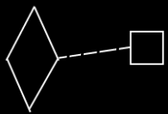

Because the definition is the prototype of the call, and not the same object as the call, a dashed class line needs to be used to point out the definition of a call.

A call does not have to be placed inside another command. It can also be placed inside an object, in case of which somebody has to run the executable object manually.